**MATH 609**

**NUMERICAL ANALYSIS**

**FALL 2022**

**LAB 03**

**MELEK DERMAN**

**832005100**

**EXERCISE I: LEAST SQUARE APPROXIMATION**

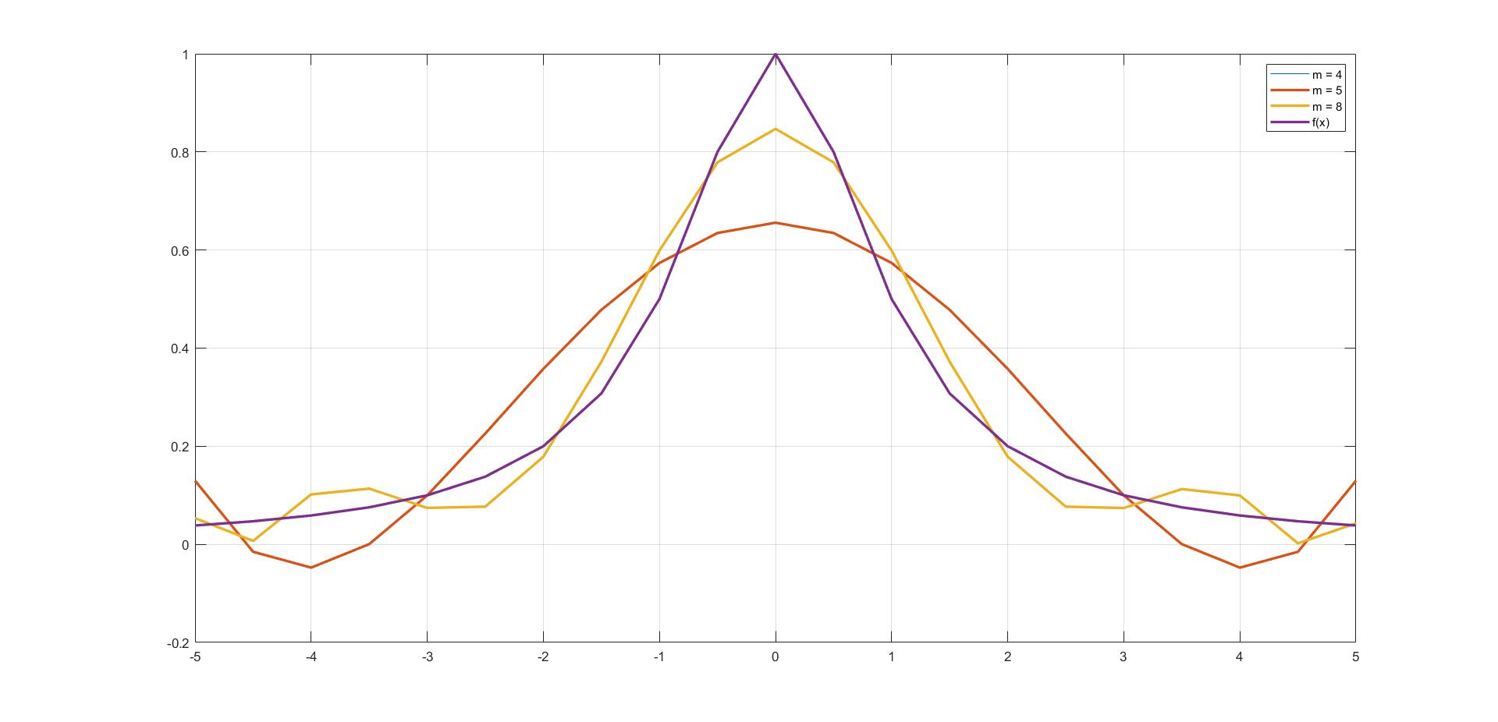

It appears that m=4 and m=5 ended up being the same plot.

**EXERCISE II: FOURIER APPROXIMATION**

**m = 5**

**f1(x) = x**

**ERROR:**

**0.004568054466118965**

**f2(x) = x(1-x)**

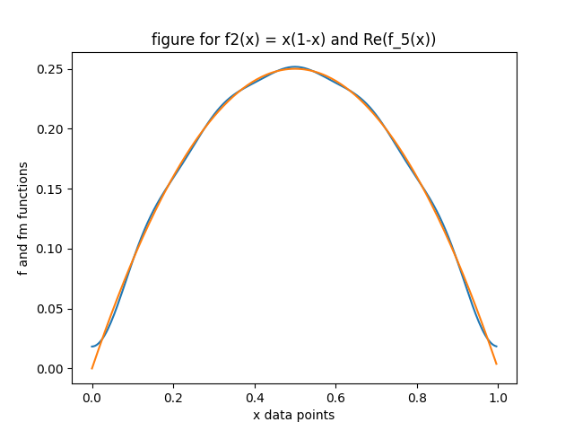

**ERROR:**

**4.448766453467944e-06**

**m = 10**

**f1(x) = x**

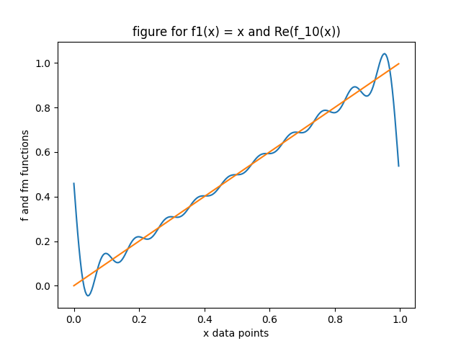

**ERROR:**

**0.002387861073653434**

**f2(x) = x(1-x)**

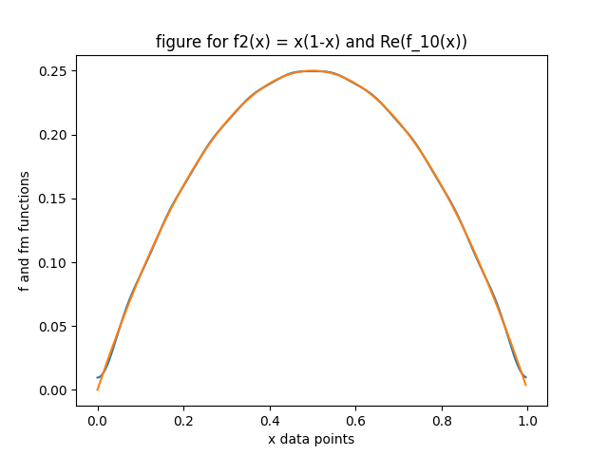

**ERROR:**

**5.804746680881285e-07**

**m = 25**

**f1(x) = x**

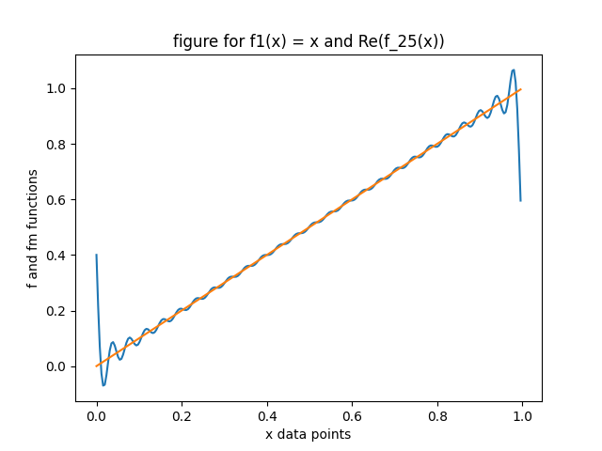

**ERROR:**

**0.0009568269202278141**

**f2(x) = x(1-x)**

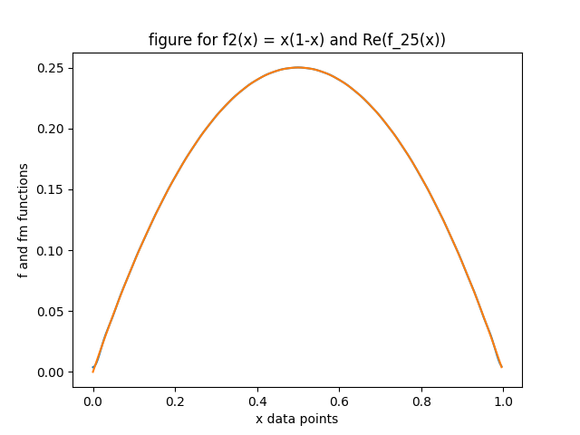

**ERROR:**

**3.245704868127345e-08**

**EXERCISE III: FOURIER TRANSFORM AND NOISY SIGNALS**

